Chip back potential is the level which bulk silicon is maintained by on-chip connection, or it is the level to which the chip back must be connected when specifically stated below. If no potential is given the chip back should be isolated.
.129”
PAD FUNCTIONS:

- V _{IN} (2 bond pads)
- V _{OUT} (2 bond pads)
- V _{OUT} SENSE
- ADJUST

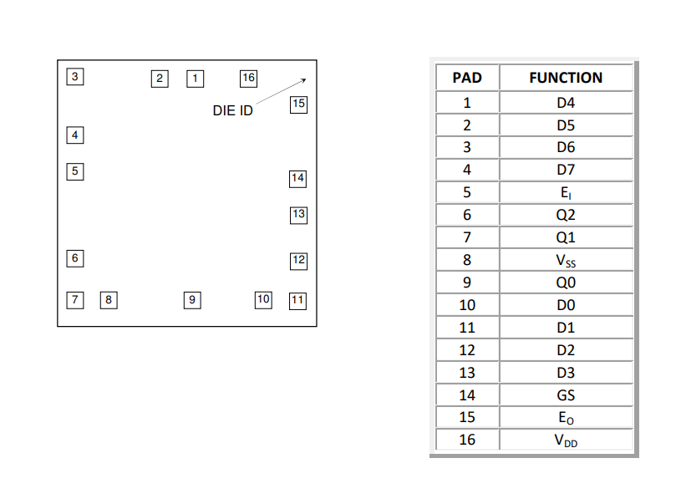
Top Material: Al
Backside Material: Si
Bond Pad Size: .004 X .004” min.
Backside Potential: VDD OR FLOAT
Mask Ref:

APPROVED BY: KW DIE SIZE .062 X .062” DATE: 1/31/23
MFG: SPRAGUE THICKNESS: .” P/N: MC14532B
DG 10.1.2

Rev B, 7/19/02

